***MODULE: 4 (JavaScript Basic & DOM)***

• What is JavaScript?

* JavaScript is a text-based programming language used both on the client-side and server-side that allows you to make web pages interactive. Where HTML and CSS are languages that give structure and style to web pages, JavaScript gives web pages interactive elements that engage a user.

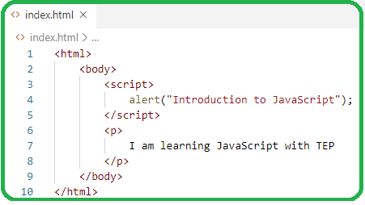

• What is the use of isNaN function?

* The JavaScript isNaN() Function is used to check whether a given value is an illegal number or not. It returns true if the value is a NaN else returns false. It is different from the Number. isNaN() Method.

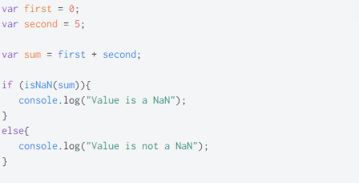

• What is negative Infinity?

* NEGATIVE_INFINITY is a special numeric value that is returned when an arithmetic operation or mathematical function generates a negative value greater than the largest representable number in JavaScript (i.e., more negative than -Number. MAX_VALUE). JavaScript displays the NEGATIVE_INFINITY value as - Infinity .

• Which company developed JavaScript?

* In September 1995, a Netscape programmer named Brandan Eich developed a new scripting language in just 10 days. It was originally named Mocha, but quickly became known as LiveScript and, later, JavaScript.



• What are undeclared and undefined variables?

* Undeclared − It occurs when a variable which hasn't been declared using var, let or const is being tried to access.

Undefined − It occurs when a variable has been declared using var, let or const but isn't given a value.

• Write the code for adding new elements dynamically?

* New elements can be created in JS by using the createElement() method. Syntax: document. createElement("<tagName>"); // Where <tagName> can be any HTML // tagName like div, ul, button, etc. // newDiv element has been created For Eg: let newDiv = document.

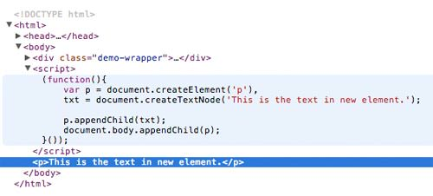

• What is the difference between ViewState and SessionState?

* The basic difference between these two is that the ViewState is to manage state at the client's end, making state management easy for end-user while SessionState manages state at the server's end, making it easy to manage content from this end too.

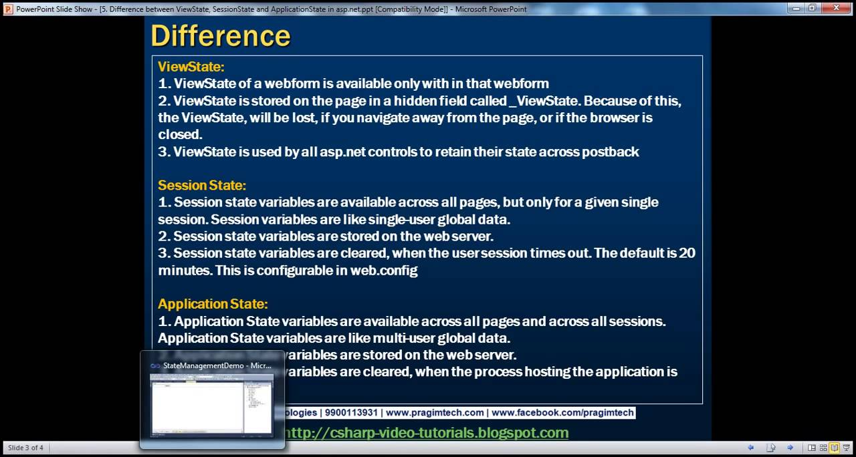

• What is === operator?

* The strict equality ( === ) operator checks whether its two operands are equal, returning a Boolean result. Unlike the equality operator, the strict equality operator always considers operands of different types to be different.

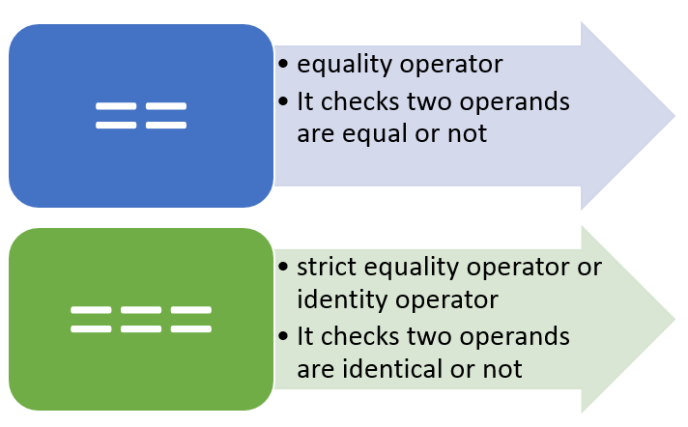

• How can the style/class of an element be changed?

* getElementById() method is used to return the element in the document with the “id” attribute and the “className” attribute can be used to change/append the class of the element.



• How to read and write a file using JavaScript?

* readFile() and rs. writeFile() methods are used to read and write of a file using javascript. The file is read using the fs. readFile() function, which is an inbuilt method.

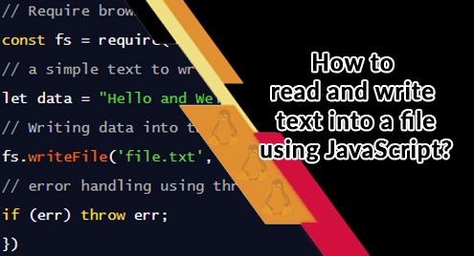

• What are all the looping structures in JavaScript?

* JavaScript supports different kinds of loops:
* for - loops through a block of code a number of times.
* for/in - loops through the properties of an object.
* for/of - loops through the values of an iterable object.
* while - loops through a block of code while a specified condition is true.

• How can you convert the string of any base to an integer in JavaScript?

* In JavaScript parseInt() function (or a method) is used to convert the passed-in string parameter or value to an integer value itself. This function returns an integer of the base which is specified in the second argument of the parseInt() function.

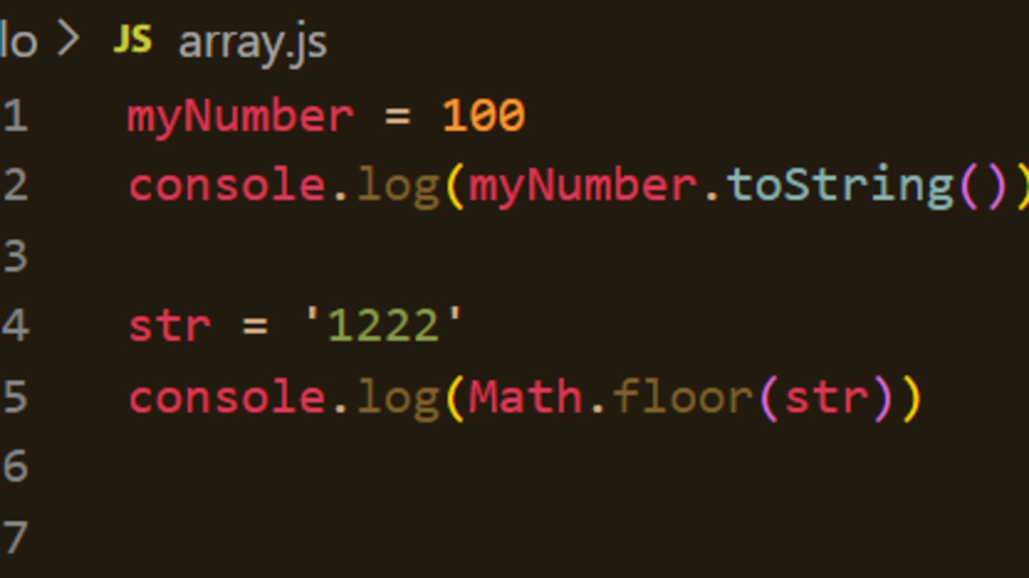

• What is the function of the delete operator?

* The delete operator removes a property from an object. If the property's value is an object and there are no more references to the object, the object held by that property is eventually released automatically.

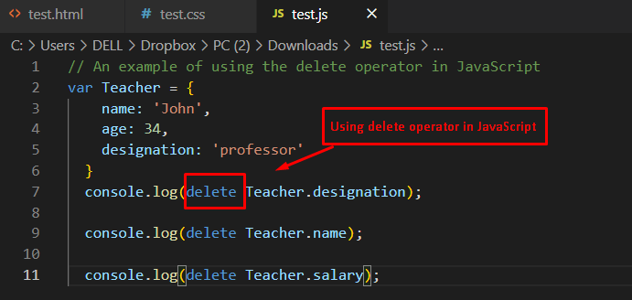

• What are all the types of Pop up boxes available in JavaScript?

* JavaScript has three kind of popup boxes: Alert box, Confirm box, and Prompt box.
* For example:

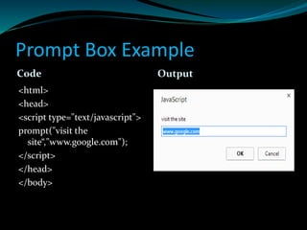

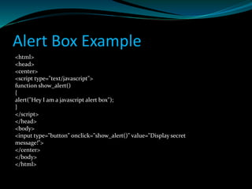

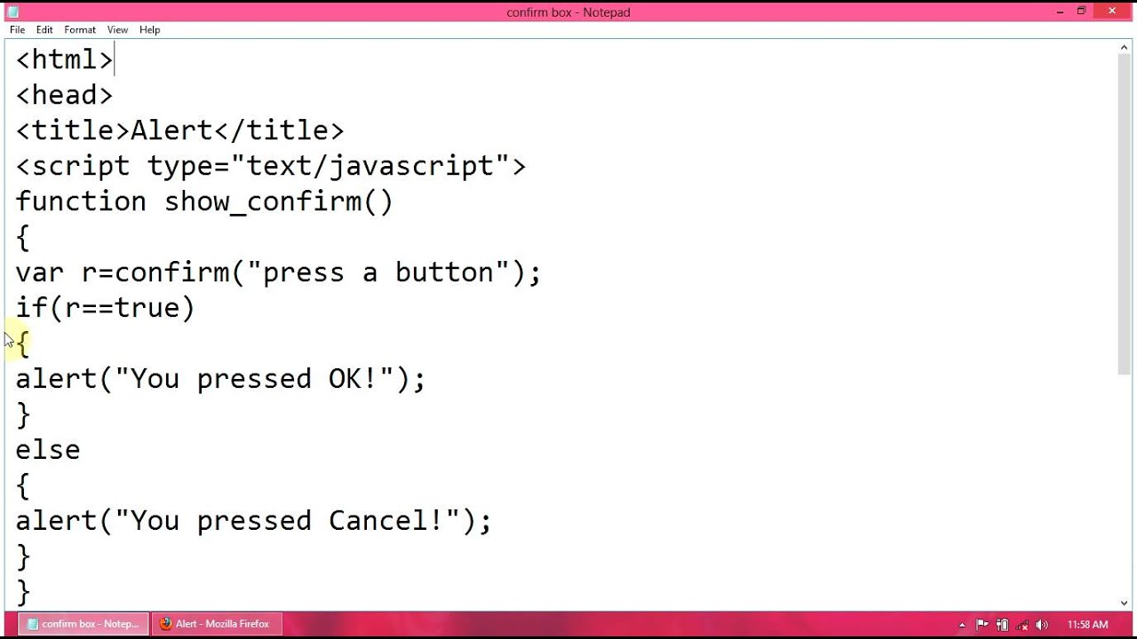

• What is the use of Void (0)?

* In a programming language, void means return nothing. “javascript: void(0)” is similar to void. javascript: void(0) means return undefined as a primitive value. We use this to prevent any negative effects on a webpage when we insert some expression.

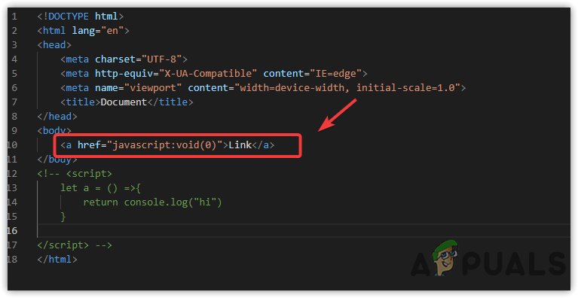

• How can a page be forced to load another page in JavaScript?

* Approach: We can use window. location property inside the script tag to forcefully load another page in Javascript. It is a reference to a Location object that is it represents the current location of the document. We can change the URL of a window by accessing it.
* Syntax:

<script>

window.location = <Path / URL>

</script>

• What are the disadvantages of using innerHTML in JavaScript?

* Disadvantages of innerHTML: -
* Event handlers attached to any DOM element are preserved.
* Replacement is done everywhere.
* It is not possible to append innerHTML.
* Breaks the document.
* Used for Cross-site Scripting.

